

A REPORT

ON

**A STUDY ON VOLATILITY IN THE INDIAN STOCK MARKET DUE TO COVID-19 PANDEMIC**

BY

TANYA TRIPATHI

Enrolment Number: 19BSP3031



**SHAREKHAN LTD**

REPORT ON

**A STUDY ON VOLATILITY IN THE INDIAN STOCK MARKET DUE TO COVID-19 PANDEMIC**

BY

TANYA TRIPATHI

Enrolment Number: 19BSP3031



**SHAREKHAN LTD**

A report submitted in partial fulfilment of

the requirements of

PGPM Program of

IBS Pune.

# Faculty Guide: Company Guide:

# Prof. Sankar Das Mr. Anil Sharma

**Date of Submission**: 25/05/2020

# AUTHORISATION

This is to certify that this report is submitted as a partial fulfilment of the requirement of PGPM Program of ICFAI Business School, Pune.

The report titled “a study on volatility on the Indian stock market due to Covid-19 Pandemic” is a submission of work done by **Tanya Tripathi** during the 14 weeks of internship at Sharekhan Pvt. Ltd. The Study has been done under the guidance of Mr**. Anil Sharma**, Territory manager at Sharekhan Pvt. Ltd. The report was prepared during a span of 14 weeks from 22nd February, 2020 to 22nd May, 2020.

This report has been formally submitted to my faculty guide, **Prof. Sankar Das,** ICFAI Business School, Pune.

**Prof. Sankar Das Mr. Anil Sharma**

*Faculty Guide TM, Company*

ICFAI Business School, Pune

**ACKNOWLEDGEMENT**

The internship with Sharekhan Pvt. Ltd. has been a great chance for learning and professional development. I consider myself lucky to have received the opportunity of working with hardworking and dedicated professionals.

I would like to express my deepest gratitude to my company guide and territory manager, Sharekhan Pvt. Ltd., **Mr. Anil Sharma, Territory Manager** for heartily welcoming me for the internship and guiding me throughout.

I express my sincere thanks to my faculty guides, **Prof. Sanakr Das, Faculty Guide** and **Dr. Neha Parashar, Dean (Examination)** for always giving the necessary guidance and advice and believing in me. This project would not have been a success without their support and patience.

My special thanks to ICFAI Business School for arranging this internship for me and helping me advance towards my career goals.

|  |  |  |
| --- | --- | --- |
| TABLE OF CONTENTS | | |
| Sr. No. | **Topic** | Page No. |
| 1 | Authorisation | 3 |
| 2 | Acknowledgement | 4 |
| 3 | Abstract | 6 |
| 4 | Executive summary | 7 |
| 5 | **Company Analysis**  5.1 Introduction to sharekhan  5.2 Market share  5.3 Financial performance  5.4 Competitors  5.5 Products and services  5.6 SWOT Analysis  **Industry analysis**  5.7 The financial services industry  5.8 Growth rate and current scenario  5.9 Major players | 8  8  9  10  10  11  11  12  12  13 |
| 6 | Main text  **6.1 Phase one:** learning at Sharekhan Ltd.  **6.2 Phase two:**  Global impact of covid-19  Impact on Indian Economy  **Industry wise analysis of impact of covid-19**  IT  Pharmaceuticals  Aviation  Retail  Tourism  Banking | 14  14-18  19-20  20-22  23-25  26-28  28-32  32-34  35-37 |
| 7 | Conclusion | 38 |
| 8 | References | 39 |

## ABSTRACT

Sharekhan is the third largest retail brokerage firm in India, after ICICI Direct and HDFC Securities. It is one of the pioneers of online trading in India. It offers a broad range of financial products and services including securities brokerage, mutual fund distribution, loan against shares, ESOP financing, IPO financing and wealth management. They execute more than four lakh trades per day. It is a fully owned subsidiary of BNP Paribas.

The initial stage of my research began with learning the technicalities of the stock market. It is essential to have a hang of how trading works and what role a brokerage firm plays. Sharekhan allows its customers access to online videos and articles which provide guidance relating to trading. The website has a plethora of features and options to make the trading experience extremely hassle free for a beginner.

Since the onset of the current Covid-19 Pandemic, I have shown keen interest, and directed my efforts towards a study on “**Volatility in the stock market due to the Covid-19 pandemic.**

The Indian stock market has been the worst hit by the novel Coronavirus because of the low investor sentiment among Indians. On 9th March,2020, the Indian stock market faced a massive crash as Sensex crashed over by 1900 points in one day.

Due to a major dependence of India on China for various raw materials, India could face a serious supply crunch of materials. This would impact the operations of big shot companies in various industries. In this project, I have selected 6 industries namely, IT, Pharma, Aviation, Tourism, Retail and Banking. For each industry, I have chosen two stocks listed on the BSE and have done an analysis on their volatility for a 6-month period. (3 months prior and post the onset of the Crisis). Since this is still a live issue, the conclusions I have drawn from the 6 month period are liable to change over a period of time.

The objectives of the study are:

* A deep insight into the role of Sharekhan as a brokerage firm
* Understanding online trading
* To study the impact of a global pandemic on the stock market indexes like NIFTY, SENSEX, etc. and subsequently on the economy.
* To analyse which industries have been the worst hit and which ones appear promising.
* To understand how a global health emergency like Covid 19 impacts investor behaviour and decisions.

## EXECUTIVE SUMMARY

Name : Tanya Tripathi

Enrolment No. : 19BSP3031

Email : [tanyatripathi19@ibsindia.org](mailto:tanyatripathi19@ibsindia.org)

Name of Organisation : Sharekhan Ltd.

Address : 2E/25 Ground Floor, Jhandewalan extension,

New Delhi, Delhi, 110055

The following report is a part of my internship at Sharekhan Ltd. and it stresses at the work experience I have gathered as an intern during my three months of internship at the company in New Delhi. Additionally, I have also made efforts to analyse the impact of the ongoing Covid-19 Pandemic on the Indian stock market.

Online trading platforms help you trade without any difficulty as these platforms enable high speed trading. These platforms have revolutionized the way trading is done. You can simply download these to your system or mobile and can begin trading.

Sharekhan Pvt. Ltd. is one of the pioneers of online trading in India. It offers a broad range of financial products and services including securities brokerage, mutual fund distribution, loan against shares, ESOP financing, IPO financing and wealth management. It is now a fully owned subsidiary of BNP Paribas, a French international banking group and one of the ten largest banks in the world.

Covid-19 has reflected the sentiments of investors in India and abroad. It has led to markets crashing around the world to the levels worse than the global financial crisis of 2008. Companies have scaled back; layoffs have multiplied and employee compensations have been affected resulting in negligible growth in the last couple of months. Sectors like hospitality, tourism and entertainment have been most adversely impacted and their stocks have plummeted.

Through my SIP title, **“ A study on volatility in the Indian stock market due to Covid-19 pandemic”,** I have made efforts to assess the disruptions caused by covid-19 in the stock market. I have made use of Excel to record changes in the share prices of stocks from the industries which have been severely impacted over a six-month period, pre and post the onset of the pandemic. Industries like aviation, tourism, retailing, entertainment are among the worst hit. On the other hand, Pharmaceuticals is among the few sectors which has boomed and shown some upward trend on the stock market. I have made use of Secondary data from online articles and newspapers

The worldwide Stock market has a history of crash and recovery and the Indian Stock Market is no different from that. It would be foolish to expect a quick recovery though since the pandemic is not over yet. Trade in 2020 is expected to fall steeply in every region of the world and basically across all sectors. But global trade could rebound rapidly after that.

## INTRODUCTION

# SHAREKHAN PVT. LTD.

It was incorporated on 20 April, 1995 and is located in Maharashtra. It is classified as a public limited company. The company has 11 directors. After ICICI Direct and HDFC Securities, It is one of the pioneers of online trading in India. It offers a broad range of financial products and services including securities brokerage, mutual fund distribution, loan against shares, ESOP financing, IPO financing and wealth management.

Sharekhan is a fully owned subsidiary of BNP Paribas, a French international banking group. BNP Paribas is the largest French banking group and the largest bank in the Eurozone. It became one of the five largest banks in the world following the 2008 financial crisis.

**COMPANY ANALYSIS**

# MARKET SHARE

The third-largest retail broking firm in the country, Sharekhan, plans on aggressive growth strategies to climb to the second spot in the online broking space over the next five years.

It also launched a new logo, in line with its Vision 2020 and post-acquisition by BNP Paribas in November 2016.

The largest standalone broking firm in India plans to double its customer base from the current 1.4 million in the next five years.

The company commands 6 per cent market share in the 25-million strong online customer segment. In terms of cash market volumes, it has a market share of 4.2 per cent.

Currently, mobile-based transactions form 12 per cent of its business. “We believe in mobile commerce. Their goal is to become the most preferred platform for digital savers and investors. The company plans to invest around €70 million.

Sharekhan also aims to launch a new website, mobile apps, hire more people, and upgrade its trading platform.

# FINANCIAL PERFORMANCE

Sharekhan Limited's operating revenues range is Over INR 500 crores for the financial year ending on 31 March, 2019. It's EBITDA has decreased by -18.28 % over the previous year. At the same time, it’s book net worth has increased by 34.12 %. The total paid-up capital is INR 58.75 crores.

According to the financial reports as on 31st March, 2019,

|  |  |
| --- | --- |
| EBITDA | -18.28 % (decrease) |
| Net worth | 34.12 % (increase) |
| Debt/Equity Ratio | 0.00 |
| Return on Equity | 3.27 % |
| Total Assets | 5.05 % (increase) |
| Fixed Assets | 13.63 % (increase) |
| Current Assets | 0.29 % (increase) |
| Current Liabilities | -17.56 % (decrease) |
| Trade Receivables | -13.70 % (decrease) |
| Trade Payables | 8.32 % ( increase) |
| Current Ratio | 1.55 |

# COMPETITORS

The major competitors of Sharekhan are

* Indiabulls securities
* Angel broking limited
* Reliance money
* Kotak securities Limited
* HDFC Securities
* India Infoline services
* ICICI Direct
* Aditya Birla Services

**PRODUCTS AND SERVICES OFFERED**

1. Choice of trading platform

* Trade Tiger
* Classic account
* Share mobile
* Share Shop
* Sharekhan mini
* Dial-n-trade

1. Investing and trading tools

* Advisory desk
* SIP
* Patter finder
* Adviseline
* Top picks
* Fortune finder
* Mutual funds
* Research
* PMS
* IPO

1. Finance

* Loan against securities
* ESOP Funding
* IPO Financing
* Margin Funding

1. Education

* FirstStep
* ATC
* Sharekhan seminars
* Learn to trade

**SWOT ANALYSIS**

**STRENGHTS**

* Excellent reputation among investors because of superior services and quick handling of customer grievances
* Efficient research and analysis team
* Abundant information about economy and stocks
* Online IPO and MUTUAL FUNDS services
* Tie ups with maximum banks
* Software expertise. Team of expert IT professionals
* Pioneer in online trading in India

**WEAKNESSES**

* Penetration and reach limited to urban areas
* Promotional activities are not at par with competitors

**OPPORTUNITIES**

* Diversification
* Modification of products
* Expansion in market share
* Educating people about benefits of investment to increase target audience
* Growing rural market and awareness among people

**THREATS**

* Close competitors like HDFC, ICICI, Motilal Oswal etc.
* Stringent economic measures by Government and RBI
* Entry of foreign finance firms in India

**INDUSTRY ANALYSIS**

# THE FINANCIAL SERVICES INDUSTRY

* Financial services are the economic services provided by the finance industry, which encompasses a broad range of businesses that manage money, including credit unions, banks, credit-card companies, insurance companies, accountancy companies, consumer-finance companies, stock brokerages, investment funds, individual managers and some government-sponsored enterprises.
* The financial services sector in India, which accounts for 6 percent of the nation’s GDP, is growing rapidly. Although the sector consists of commercial banks, development finance institutions, nonbanking financial companies, insurance companies, cooperatives, mutual funds, and the new “payment banks,” it is dominated by banks, which holds over 60 percent share.
* The Reserve Bank of India (RBI) is the apex bank of the country, controlling all activities in the financial sector. Commercial banks include public sector and private sector banks and are under the regulatory supervision of the RBI. Development finance institutions include industrial and agriculture banks.
* Non-banking finance companies (NBFC) provide loans, purchase stocks and debentures, and offer leasing, hire purchase, and insurance services.
* Insurance companies function in both public and private sectors and are controlled by the Insurance Regulatory and Development Authority (IRDA).
* India also has a vibrant capital market with stocks exchanges controlled by the Securities and Exchange Board of India (SEBI).

# GROWTH RATE AND CURRENT SCENARIO

* The present growth rate of financial sector in India is about 8.5% p.a. An increase in growth rate is equivalent to growth of our economy. Over the past few years, there have been reforms in monetary policies, economic policies, opening up of financial markets, development of other financial sectors etc. In present times, a wide variety of financial products and services are offered to consumers to keep them satisfied. The Reserve Bank of India has also played a major role to help in the growth of financial sector of India.
* Volatility in the financial markets has resulted in financial institutions struggling to maintain their growth and profitability. Alongside, the global economic slowdown has taken a toll on the Indian economy, pressurising margins as well as the very sustainability of financial service companies. These dynamics call for the need to establish robust business models and ensure quality management.

# MAJOR PLAYERS

* Financial service sector comes under the tertiary sector in which **banks play a major role**. For the growth of financial services industry, banks are led by the **central bank** of the country followed by commercial banks, co-operative banks, development banks, foreign banks, etc.
* [**Hire purchase financier**](https://accountlearning.com/status-of-hire-purchase-in-india/) is also a player in the financial service sector as he enables the consumer to buy the product on credit basis.
* [**Leasing companies**](https://accountlearning.com/different-types-of-leasing/) through financial and operating lease ensure the acquiring of assets by producers on a long-term basis at a reasonable charge
* [**Factoring**](https://accountlearning.com/factoring-in-small-business/) enables the seller to obtain 80% value of sales from the financial companies undertaking factoring services.
* **Underwriters and merchant bankers** are additional players who promote not only companies but also ensure dynamic activity in the [capital market](https://accountlearning.com/factors-influencing-international-capital-market/).
* **Book-builders** help companies in allotting shares to different categories of investors.
* **Mutual funds** ensure investment by the public and also ensure tax relief to the investor.
* **Credit cards**, another important player in the financial services, ensure the circulation of plastic money and enable purchase on credit by the consumer.
* [**Credit rating companies**](https://accountlearning.com/functions-of-credit-rating-agencies/) play an important role by giving different credit ratings to companies to mobilize public deposits.
* [**Housing finance companies**](https://accountlearning.com/housing-finance-advantages-methods-of-financing-tax-benefits/) and insurance companies also promote investment in the economy as they also form a part of the players in the financial services.
* **Asset liability management company** enables mutual funds to undertake proper investment in different types of companies.
* **Finance companies** in general and also as a part of [non-banking finance companies](https://accountlearning.com/banking-company-vs-non-banking-company-including-nbfcs/) provide additional funds to the above players so that there is more activity in the economy.

## MAIN TEXT

**PHASE 1**

* Over the first phase of the SIP, the major focus was on classroom learning. An in depth understanding of the various concepts and terms related to the stock market is crucial before dealing with customers. Some important terms taught to us are:
* Bearish and bullish market
* Buy/sell/bid/settlement time
* Market order/limit order/day order
* IPO/equity account/Demat account
* Nifty/Sensex/SEBI/IRDA
* Futures and options
* Index/execution/margin/quote
* Short selling/squaring off
* Major scams like Harshad Mehta, Sahara, NSEL
* The Share khan application provides a separate section called Share khan classroom which has video lectures explaining all the basic concepts. We were instructed to watch them to understand what mutual funds, IPO, and other terms are and how trading is done.
* Each of us had a Demat account opened with Sharekhan to learn trading and place orders for shares. Invested in SBI shares for practical experience.
* Following stock market news on money control, NSE, BSE, Livemint etc.

**PHASE 2**

* This part of the research involves a detailed study of “The **volatility in the Indian** **stock market due to Covid-19 pandemic”**

**The objective of the study is :**

* To study the impact of a global pandemic on the stock market indexes like NIFTY, SENSEX, etc. and subsequently on the economy.
* To analyse which industries have been the worst hit and which ones appear promising.
* To understand how a global health emergency like Covid 19 impacts investor behaviour and decisions

**GLOBAL IMPACT OF COVID-19**

* Covid-19 is a health crisis which has forced governments across the world to take strict measures to contain the movement of people and enforce lockdowns.
* Due to halt in all economic activities, there has been unavoidable decline in trade and output which has had painful consequences for households and businesses.
* Some important pointers concerning decline in world trade are:
* World merchandise trade expected to fall between 13% and 32% in 2020 due to Covid-19
* Services trade most directly affected due to travel and transport restrictions
* Nearly all regions will suffer double-digit declines in trade volumes in 2020, with exports from North America and Asia hit hardest.

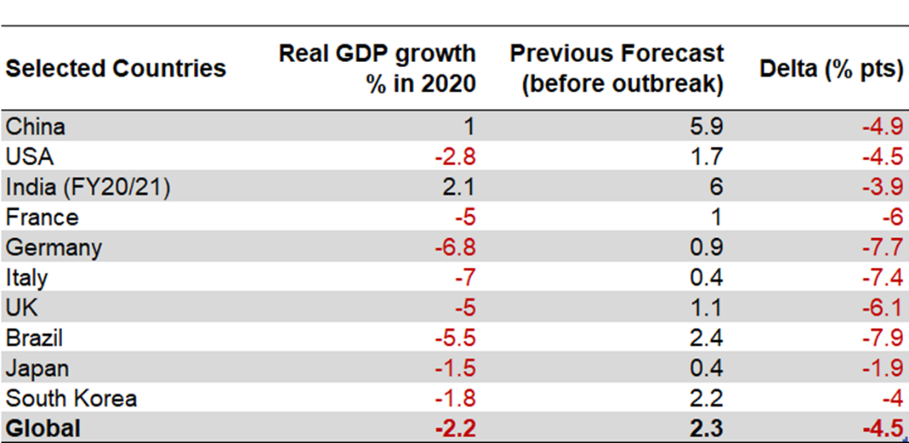

Source: Economist Intelligence Unit

e/ ;

D

* The above data shows that there has been a severe impact on the forecasted GDP growth of countries across the world. The global economy is expected to shrink by 1% this year due to restrictions on economic activities and service sector. Annual GDP growth is expected to fall to 2.4% in 2020 from an already weak growth of 2.9% in 2019.
* The shutdown of economic activity and production in China has majorly impacted the operations in major countries, thus highlighting the dependence on China of global supply chains.

**IMPACT ON MANUFACTURING**

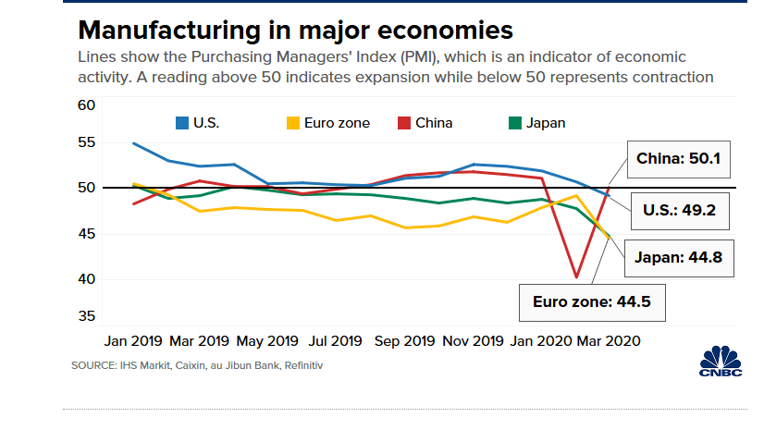

* The Purchasing Managers' Index (PMI) is an index of the prevailing direction of economic trends in the manufacturing and service sectors. It summarizes whether market conditions, as viewed by purchasing managers, are expanding, staying the same, or contracting.
* The purpose of the PMI is to provide information about current and future business conditions to company decision makers, analysts, and investors
* As is evident in the picture above, the manufacturing industry in China plunged sharply between january and march 2020. Such slowdown has also affected the economies which have close links with China, like Vietnam, Singapore and South Korea.

**IMPACT ON SERVICES**

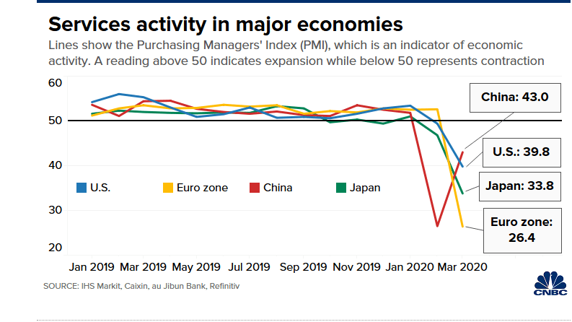

* Besides China, the services sector in U.S., the world’s largest consumer market also contracted in February. The major reason was the reduction in new business from abroad as customers started holding back from placing orders because of global economic uncertainty due to the pandemic outbreak.
* The IHS Markit India Services Business Activity Index recorded 49.3 in March, down from February’s 85-month high of 57.5. The major reason for the fall was a fall in new orders, particularly from the overseas.
* The level of employment across the Indian services sector fell as companies cut workforce numbers to control operating costs.

**IMPACT ON STOCK MARKETS**

* The stock markets have responded to covid-19 with volatility as traders have panic sold out of fear.
* China, where the Virus emerged, has been the least affected with only 3% fall in the stock market between February and April.
* U.S. and European markets were relatively late to appreciate the severity of the coronavirus. U.S. stocks actually increased in value throughout early February even as the virus was spreading throughout the country.
* In March, U.S. stock markets shortly thereafter started to experience the most significant turmoil since the Great Recession, crashing so hard as to trip the circuit breakers and automatically halt trading.
* The Dow Jones and S&P 500 have both been seeing drops due to uncertainty because of Covid-19. Dow Jones saw two of the largest single day drops in March.
* Trading halted on both Dow Jones and Nasdaq for 15 mins on 16th March, 2020 after the S&P dropped 8%.
* 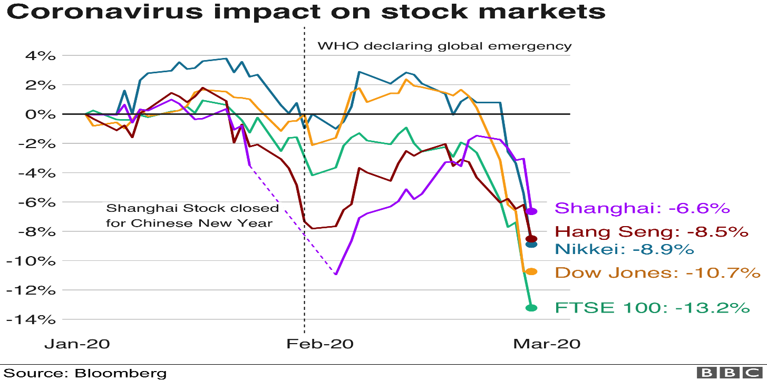The Indian stock market has been worst affected (26% fall) from the crisis because of low investor sentiment.

**IMPACT ON INDIAN ECONOMY**

* The corona virus outbreak has severely disrupted the Indian economy**.**  The World Bank estimated the Indian economy to decelerate to 5 per cent in 2020 and projected a sharp growth deceleration in fiscal 2021 to 2.8 per cent in a baseline scenario.
* **Demand side impact on the economy includes-**

**Private consumption**. There has been a steep fall in the consumption of non-essential goods. Industries like hotels, entertainment, retail, aviation and tourism have been worst hit due to their closure by the government.

* **Supply side impact includes-**

Shutdown of factories, delay in supply of goods, causing disruption in supply chains. Also, a shortage of raw materials being imported by various companies from China. Companies are trying hard to maintain a smooth flow of goods, but with the halt in manufacturing, their inventory will not last long.

* The coronavirus pandemic, which resulted in the world’s biggest lockdown and threatens slowest growth since the global financial crisis, led to a huge fall in the Indian stock market.
* The plunge in the SENSEX due to Covid-19 has been the fastest as compared to that caused by the 2008 crisis or dotcom bust.



* The current Sensex fall of nearly 32% has been the fastest—from 14,953 on 14 January to 28,288 on 19 March compared with historical dips. Be it the dotcom bust, 2008 crisis or Harshad Mehta scam, the falls were gradual and extended over months.
* The major reason behind SENSEX Crash was relentless selling by investors due to panic because of the rising cases in India. There has been mass dumping of Indian shares by foreign investors.

**INDUSTRY WISE ANALYSIS OF THE IMPACT OF COVID-19**

* **For the purpose of analysis, I have chosen six industries in total and two companies from each industry (12 companies).**
* **I have worked on excel to show the effect of Covid -19 on the stocks of companies. A comparison has been made between pre Covid-19 and post the onset of Covid-19 on the weekly closing prices of stocks.**

1. **INFORMATION TECHNOLOGY**

* Though not worst hit by covid-19, the IT sector can face indirect impact from China’s economic slowdown.
* The Indian IT sector gets most of its revenue from the US and European markets. Its fortunes are closely linked to the economic well-being of the economies of the western hemisphere. Since there has been a huge disruption in the US and European economies, it has had a major impact on the Indian companies too.
* The growth prospects in the IT sector remain slim due to the upcoming scare of a global recession.
* The Indian IT industry is part of a global supply chain; any disruption in the latter will have a ripple effect here. The impact of Covid-19 will be worse than Global Financial Crisis as the former has affected both demand and supply, whereas the latter had affected only demand.

**BEFORE COVID-19**

|  |  |  |  |  |
| --- | --- | --- | --- | --- |
| **DATE** | **INFOSYS** | **INFOSYS** | **TCS** | **TCS** |
| **30-Sep-19** | 805.65 |  | 2058.26 |  |
| **01-Oct-19** | 793.55 | -2% | 2059.7 | 0% |
| **07-Oct-19** | 789.55 | -1% | 2052.85 | 0% |
| **14-Oct-19** | 785.65 | 0% | 2020.95 | -2% |
| **22-Oct-19** | 643.3 | -18% | 2051.65 | 2% |
| **29-Oct-19** | 650.6 | 1% | 2196 | 7% |
| **05-Nov-19** | 695.8 | 7% | 2201.6 | 0% |
| **11-Nov-19** | 704.5 | 1% | 2099.7 | -5% |
| **18-Nov-19** | 705.55 | 0% | 2151.75 | 2% |
| **25-Nov-19** | 698 | -1% | 2080.2 | -3% |
| **02-Dec-19** | 692.9 | -1% | 2020.95 | -3% |
| **09-Dec-19** | 716.9 | 3% | 2060.7 | 2% |
| **16-Dec-19** | 714 | 0% | 2127.55 | 3% |
| **23-Dec-19** | 735.85 | 3% | 2232.45 | 5% |
| **30-Dec-19** | 732.8 | 0% | 2182.9 | -2% |

**DURING COVID-19**

|  |  |  |  |  |
| --- | --- | --- | --- | --- |
| **DATE** | **INFOSYS** | **INFOSYS** | **TCS** | **TCS** |
| **31-Dec-19** | 731.75 |  | 2161.3 |  |
| **01-Jan-20** | 736.9 | 0.70% | 2169.8 | 0.39% |
| **08-Jan-20** | 718.15 | -2.54% | 2255.05 | 3.93% |
| **15-Jan-20** | 767.7 | 6.90% | 2226.55 | -1.26% |
| **22-Jan-20** | 769.95 | 0.29% | 2206.5 | -0.90% |
| **29-Jan-20** | 789.45 | 2.53% | 2152.7 | -2.44% |
| **05-Feb-20** | 784.5 | -0.63% | 2145.25 | -0.35% |
| **12-Feb-20** | 781.05 | -0.44% | 2170.5 | 1.18% |
| **19-Feb-20** | 800.7 | 2.52% | 2194.6 | 1.11% |
| **26-Feb-20** | 782.7 | -2.25% | 2123.05 | -3.26% |
| **04-Mar-20** | 758.6 | -3.08% | 2083.15 | -1.88% |
| **11-Mar-20** | 685.15 | -9.68% | 1954.55 | -6.17% |
| **18-Mar-20** | 535.05 | -21.91% | 1650.95 | -15.53% |
| **25-Mar-20** | 605.95 | 13.25% | 1752.2 | 6.13% |
| **01-Apr-20** | 604.1 | -0.31% | 1709.55 | -2.43% |
| **08-Apr-20** | 631.7 | 4.57% | 1705.6 | -0.23% |

* As is evident from the above data, post the onset of Covid-19 in India in the month of March, the stocks of both Infosys and TCS have shown a fall in the closing prices.
* The share prices of Infosys plunged between **11th to 18th March** because of temporary suspension in operations due to an employee being tested positive for Covid-19 and due to disrupted global trade. Also, there had been technical issues with the GST Network. Infosys is the technical supporter of GSTN.
* However, the share prices recovered for both companies for of strong client base and maintenance of gross margins and high EBIT.

1. **PHARMACEUTICALS**

* India’s manufacturers rely heavily on imports of their APIs from China. As a result of the lockdowns and closures, slowed production of APIs resulted in less availability and higher costs for the materials required for generics production.
* The pharmaceutical sector faces supply disruptions due to closure of factories in China which provides majority of raw ingredients for production of drugs in India.
* Another challenge faced is interstate transport inconvenience. Due to the lockdown imposed by the government, many retailers are not able to procure the required stock from states like Goa, Sikkim and Baddi which produce a major chunk of medicines.

**BEFORE COVID-19**

|  |  |  |  |  |
| --- | --- | --- | --- | --- |
| **DATE** | **CIPLA** | **CIPLA** | **IPCA LABS LTD.** | **IPCA LABS LTD.** |
| **30-Sep-19** | 425.05 |  | 901.9 |  |
| **1 0ct 2019** | 412.45 | -2.96% | 892.4 | -1.05% |
| **7 0ct 2019** | 408.55 | -0.95% | 875.4 | -1.90% |
| **14-Oct-19** | 440.85 | 7.91% | 890.15 | 1.68% |
| **22-Oct-19** | 453.75 | 2.93% | 927.45 | 4.19% |
| **29 0ct 2019** | 473.25 | 4.30% | 983.15 | 6.01% |
| **05-Nov-19** | 467.6 | -1.19% | 994.3 | 1.13% |
| **11-Nov-19** | 454.5 | -2.80% | 1090.8 | 9.71% |
| **18-Nov-19** | 459.75 | 1.16% | 1161.9 | 6.52% |
| **25-Nov-19** | 483.35 | 5.13% | 1101.5 | -5.20% |
| **02-Dec-19** | 464.35 | -3.93% | 1130.05 | 2.59% |
| **09-Dec-19** | 447.75 | -3.57% | 1094.05 | -3.19% |
| **16-Dec-19** | 458.6 | 2.42% | 1125.8 | 2.90% |
| **23-Dec-19** | 467.75 | 2.00% | 1128.1 | 0.20% |
| **30-Dec-19** | 479.8 | 2.58% | 1136.65 | 0.76% |

**DURING COVID-19**

|  |  |  |  |  |
| --- | --- | --- | --- | --- |
| **DATE** | **CIPLA** | **CIPLA** | **IPCA LAB LTD.** | **IPCA LAB LTD.** |
| **31-Dec-19** | 478.45 |  | 1134.9 |  |
| **01-Jan-20** | 476.05 | -0.50% | 1138.2 | 0.29% |
| **08-Jan-20** | 464.55 | -2.42% | 1197.85 | 5.24% |
| **15-Jan-20** | 483.7 | 4.12% | 1249.05 | 4.27% |
| **22-Jan-20** | 471.75 | -2.47% | 1229.3 | -1.58% |
| **29-Jan-20** | 461.35 | -2.20% | 1230.45 | 0.09% |
| **05-Feb-20** | 446.8 | -3.15% | 1220.65 | -0.80% |
| **12-Feb-20** | 446.75 | -0.01% | 1326.85 | 8.70% |
| **19-Feb-20** | 447.45 | 0.16% | 1407.85 | 6.10% |
| **26-Feb-20** | 422.45 | -5.59% | 1373.65 | -2.43% |
| **04-Mar-20** | 447.7 | 5.98% | 1427.7 | 3.93% |
| **11-Mar-20** | 417.55 | -6.73% | 1409.9 | -1.25% |
| **18-Mar-20** | 386.7 | -7.39% | 1282.25 | -9.05% |
| **25-Mar-20** | 376.7 | -2.59% | 1305.05 | 1.78% |
| **01-Apr-20** | 413.55 | 9.78% | 1394.7 | 6.87% |
| **08-Apr-20** | 513 | 24.05% | 1615.8 | 15.85% |

* The pharma industry has outperformed the broader market both on NSE and BSE. In the month of month, the healthcare sector on BSE has overall gained 473 points or 3.5%.
* The stocks of Cipla rose over 5%
* Nifty Pharma index was the sole gainer among the sectoral indices.
* The rise in the share prices in the Pharma industry have been due to a rise in demand for generic drugs
* Also, the stock prices of IPCA labs increased because of the government removing ban on export of hydroxychloroquine to the US and other countries. IPCA Laboratories is one of the major producers of hydroxychloroquine in the country.
* US approved three of IPCA factories to supply hydroxychloroquine and raw materials on **21 March.** This has caused the share prices to rise to soar substantially from March onwards.
* There was a slump in the share prices of Cipla in March because of halt in manufacturing in China.
* Also, Cipla has failed to perform well during the last 5 years. Its share prices share prices have started falling from **26th February onwards** because it received a warning letter from the US food and drug administration due to non-compliance of good manufacturing practices.
* The rise in Cipla’s share prices in **the first week of April** is because it had received final approval from the US health regulator for Albuterol Sulfate Inhalation Aerosol used in the treatment of bronchospasm or prevention of asthmatic symptoms. There is expected to be $45 million generation of revenue in the start of 2021.

1. **AVIATION**

* Aviation is among the worst affected sectors from Covid-19 all over the world.
* Some companies have reported more than 30% drop in domestic travel this summer in comparison to last year. Airlines have reduced airfares by 20 to 25%.

**BEFORE COVID-19**

|  |  |  |  |  |
| --- | --- | --- | --- | --- |
| **DATE** | **SPICEJET** | **SPICEJET** | **INDIGO** | **INDIGO** |
| **30-Sep-19** | 125.15 |  | 1891.65 |  |
| **01-Oct-19** | 122.85 | -1.84% | 1870.85 | -1.10% |
| **07-Oct-19** | 119.3 | -2.89% | 1795.55 | -4.02% |
| **14-Oct-19** | 122.4 | 2.60% | 1767.2 | -1.58% |
| **22-Oct-19** | 117 | -4.41% | 1673.9 | -5.28% |
| **29-Oct-19** | 115.55 | -1.24% | 1410.3 | -15.75% |
| **05-Nov-19** | 116.9 | 1.17% | 1461.45 | 3.63% |
| **11-Nov-19** | 115.05 | -1.58% | 1479.75 | 1.25% |
| **18-Nov-19** | 116 | 0.83% | 1458.9 | -1.41% |
| **25-Nov-19** | 109.65 | -5.47% | 1450.45 | -0.58% |
| **02-Dec-19** | 103.75 | -5.38% | 1451.45 | 0.07% |
| **09-Dec-19** | 105.6 | 1.78% | 1327.45 | -8.54% |
| **16-Dec-19** | 103.35 | -2.13% | 1300.35 | -2.04% |
| **23-Dec-19** | 92.85 | -10.16% | 1300.55 | 0.02% |
| **30-Dec-19** | 110.45 | 18.96% | 1343.35 | 3.29% |

**DURING COVID-19**

|  |  |  |  |  |
| --- | --- | --- | --- | --- |
| **DATE** | **SPICEJET** | **SPICEJET** | **INDIGO** | **INDIGO** |
| **31-Dec-19** | 112.7 |  | 1333.2 |  |
| **01-Jan-20** | 116.4 | 3.28% | 1333.8 | 0.05% |
| **08-Jan-20** | 99.25 | -14.73% | 1352.7 | 1.42% |
| **15-Jan-20** | 104.4 | 5.19% | 1446.55 | 6.94% |
| **22-Jan-20** | 97.85 | -6.27% | 1468.65 | 1.53% |
| **29-Jan-20** | 98.85 | 1.02% | 1462.2 | -0.44% |
| **05-Feb-20** | 92.65 | -6.27% | 1450.15 | -0.82% |
| **12-Feb-20** | 87.9 | -5.13% | 1442 | -0.56% |
| **19-Feb-20** | 87.65 | -0.28% | 1481.15 | 2.71% |
| **26-Feb-20** | 88.85 | 1.37% | 1394.05 | -5.88% |
| **04-Mar-20** | 70.9 | -20.20% | 1200.6 | -13.88% |
| **11-Mar-20** | 60.35 | -14.88% | 1155.45 | -3.76% |
| **18-Mar-20** | 37.85 | -37.28% | 952.25 | -17.59% |
| **25-Mar-20** | 33.9 | -10.44% | 1011.4 | 6.21% |
| **01-Apr-20** | 38.7 | 14.16% | 999.75 | -1.15% |
| **08-Apr-20** | 44.7 | 15.50% | 990.1 | -0.97% |

* Shares of aviation majors like IndiGo and SpiceJet tanked by 19% when the government imposed travel curbs across the country.
* Even with the relief to airlines due to decline in crude oil prices, the slump in demand has affected them the worst.
* The fall in the share prices of SpiceJet can be seen from the **second week of November**. This has been due to factors like increasing cost pressures and a decrease in passenger growth as compared to an increase in its capacity growth. Also, there were reports that the company was facing liquidity crunch. The company reported losses of around INR 463 crores.
* Hundreds of cancelled flights and decline in ticket bookings caused the share prices plunge in March.
* SpiceJet had cash and cash equivalents of about ₹93 crores as on **30 September** and a negative net worth of ₹850 crores. The company’s shares were crashing already and it was in dire need of funds. Covid 19 has made the situation worse.
* The shares of Indigo Airlines fell in the **starting week of October** by 4% due to announcements of differences between the promoters of the company.
* The share prices have fallen sharply between **14th and 29th October** because of a fall in the market share of IndiGo to 47.4%.
* We can see a sharp fall in share prices in the week between **19th February and 26th February.** This has been because global rating firm Credit Suisse has cut the earnings estimates for FY20, FY21, FY 22 by 83%, 31% and 18% respectively
* Inter Globe Aviation, saw its shares fall by 14.08 per cent to hit a 52-week low of INR 875 in the week between **11th and 18th march**. This has been due to cancellation of flights and travel bans.

1. **RETAIL**

**I have taken one stock from the supermarket sector and another from the fashion and apparel sector, since both have been affected in the retail industry.**

* Even before the covid-19 crisis, Indian retailers were having a tough time attracting consumers to spend more, due to the demand slump. The 21day lockdown worsened the situation.
* The retail industry will take about a year to revive, especially the apparel and fashion segment which comes under discretionary products category. Most of the food retailers have started delivering essential commodities and reducing employee costs.

**BEFORE COVID-19**

|  |  |  |  |  |
| --- | --- | --- | --- | --- |
| **DATE** | **AVENUE SUPERMART** | **AVENUE SUPERMART** | **SHOPPERS STOP** | **SHOPPERS STOP** |
| **30-Sep-19** | 1859.75 |  | 425.05 |  |
| **01-Oct-19** | 1894.4 | 1.86% | 429.1 | 0.95% |
| **07-Oct-19** | 1846.55 | -2.53% | 416.35 | -2.97% |
| **14-Oct-19** | 1828.15 | -1.00% | 413 | -0.80% |
| **22-Oct-19** | 1913.8 | 4.69% | 398.6 | -3.49% |
| **29-Oct-19** | 1940.1 | 1.37% | 365.85 | -8.22% |
| **05-Nov-19** | 1976.3 | 1.87% | 375 | 2.50% |
| **11-Nov-19** | 1964.9 | -0.58% | 367.7 | -1.95% |
| **18-Nov-19** | 1827.25 | -7.01% | 358 | -2.64% |
| **25-Nov-19** | 1837.4 | 0.56% | 342.25 | -4.40% |
| **02-Dec-19** | 1844 | 0.36% | 351 | 2.56% |
| **09-Dec-19** | 1781.95 | -3.36% | 350.6 | -0.11% |
| **16-Dec-19** | 1770.8 | -0.63% | 350.15 | -0.13% |
| **23-Dec-19** | 1921.85 | 8.53% | 350.15 | 0.00% |
| **30-Dec-19** | 1883.05 | -2.02% | 372 | 6.24% |

**DURING COVID-19**

|  |  |  |  |  |
| --- | --- | --- | --- | --- |
| **DATE** | **AVENUE SUPERMART** | **AVENUE SUPERMART** | **SHOPPERS STOP** | **SHOPPERS STOP** |
| **31-Dec-19** | 1838.2 |  | 370.85 |  |
| **01-Jan-20** | 1827 | -0.61% | 370.35 | -0.13% |
| **07-Jan-20** | 1815.15 | -0.65% | 370 | -0.09% |
| **14-Jan-20** | 1930 | 6.33% | 391.9 | 5.92% |
| **21-Jan-20** | 1916.85 | -0.68% | 426.7 | 8.88% |
| **28-Jan-20** | 1929.3 | 0.65% | 421 | -1.34% |
| **04-Feb-20** | 2155.45 | 11.72% | 404.55 | -3.91% |
| **11-Feb-20** | 2394.65 | 11.10% | 393.6 | -2.71% |
| **18-Feb-20** | 2365.3 | -1.23% | 383.9 | -2.46% |
| **25-Feb-20** | 2330.7 | -1.46% | 384 | 0.03% |
| **03-Mar-20** | 2229.3 | -4.35% | 374 | -2.60% |
| **09-Mar-20** | 2138.8 | -4.06% | 361.6 | -3.32% |
| **16-Mar-20** | 2011.55 | -5.95% | 278 | -23.12% |
| **23-Mar-20** | 1826.95 | -9.18% | 198.25 | -28.69% |
| **30-Mar-20** | 2115.7 | 15.81% | 201 | 1.39% |
| **08-Apr-20** | 2299.65 | 8.69% | 194 | -3.48% |

* Retail stores in malls are also facing major rental costs.
* The shares of Avenue Supermarket show a fall in the month of December from **2nd to 16th,** due to slow revenue growth beginning from July.
* There has been a huge rise in share prices (11%) between **4th February to 11th February** after the company launched a qualified institutional placement on February 5th.
* The fact that Avenue Supermart gets a majority of its revenue from the sale of products in the essentials category has turned out to be a saviour for the company.
* But even then, its operations have been badly hit by the lockdown, since 50 % of DMART stores have been shut down.
* As can be seen, the share prices dropped steeply from **3rd of March till the end of the month.** The reasons are low footfall, no online presence till the month of April.
* But the company has still faced respite due to consumers stocking up essential items and groceries. The share prices saw good recovery in the month of April due to DMART starting online delivery of essentials.
* The major reason for the fall in the share prices of Avenue Supermarts is the profit margin lost from the apparel and general merchandise segment.

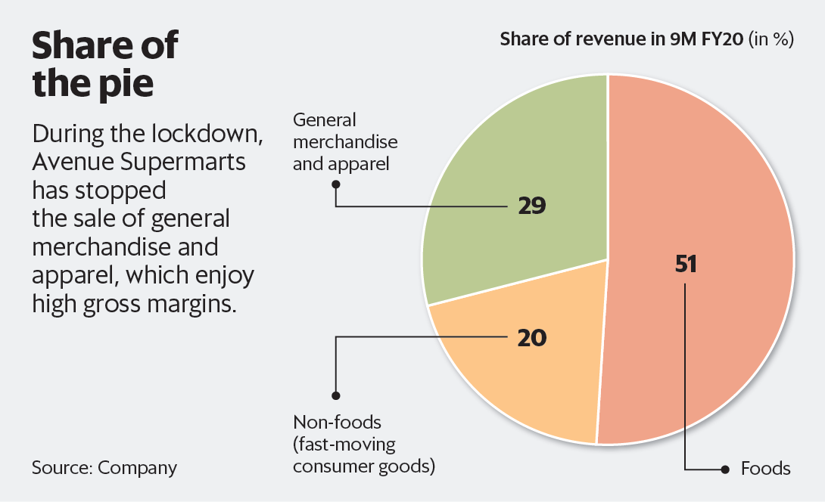

* Shares of Shoppers Stop have dipped 5% between 22**nd to 29th October**, 2019 due to reported net losses of around INR 8 crores.
* As can be seen in the image, the shares of Shoppers Stop suffered a major drop in value between **16th and 23rd of March.** (23% to 28%) due to closure of retail outlets and malls across the country.
* Shares of Shoppers Stop have fallen by approx. 50% from their high in February.

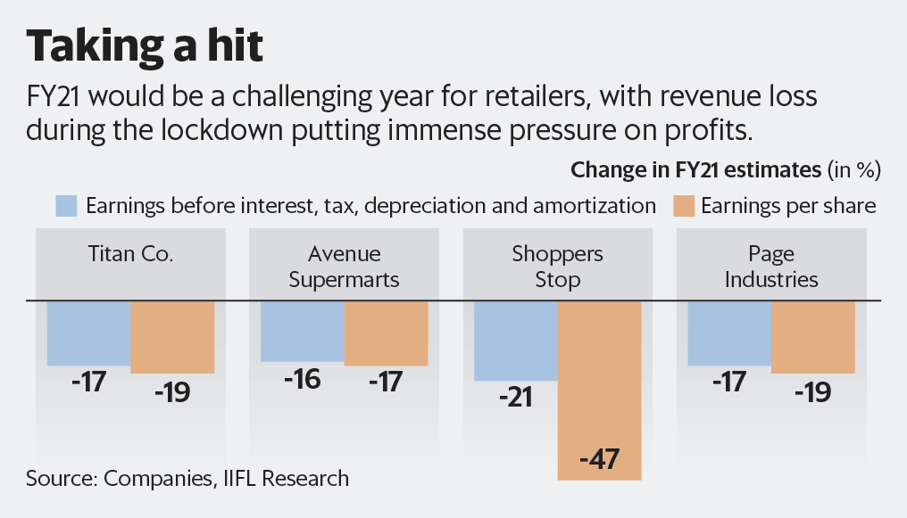

1. **TOURISM**

* The tourism industry has been the first to be hit and stares at a huge number of job losses of around 38 million.

**BEFORE COVID-19**

|  |  |  |  |  |
| --- | --- | --- | --- | --- |
| **DATE** | **INDIAN HOTELS** | **INDIAN HOTELS** | **THOMAS COOK** | **THOMAS COOK** |
| **30-Sep-19** | 159.7 |  | 135.2 |  |
| **01-Oct-19** | 153.25 | -4.04% | 141.1 | 4.36% |
| **07-Oct-19** | 156.15 | 1.89% | 141.55 | 0.32% |
| **14-Oct-19** | 152.15 | -2.56% | 137.5 | -2.86% |
| **22-Oct-19** | 152.25 | 0.07% | 119.3 | -13.24% |
| **29 0ct 2019** | 151.2 | -0.69% | 119.6 | 0.25% |
| **05-Nov-19** | 151.1 | -0.07% | 128.7 | 7.61% |
| **11-Nov-19** | 146.5 | -3.04% | 135.2 | 5.05% |
| **18-Nov-19** | 153.85 | 5.02% | 139.3 | 3.03% |
| **25-Nov-19** | 151.35 | -1.62% | 153.1 | 9.91% |
| **02-Dec-19** | 148.7 | -1.75% | 160.05 | 4.54% |
| **09-Dec-19** | 148 | -0.47% | 66.2 | -58.64% |
| **16-Dec-19** | 146.05 | -1.32% | 66.1 | -0.15% |
| **23-Dec-19** | 144.15 | -1.30% | 68.9 | 4.24% |
| **30-Dec-19** | 143.85 | -0.21% | 64.25 | -6.75% |

**DURING COVID-19**

|  |  |  |  |  |
| --- | --- | --- | --- | --- |
| **DATE** | **INDIAN HOTELS** | **INDIAN HOTELS** | **THOMAS COOK** | **THOMAS COOK** |
| **31-Dec-19** | 145 |  | 63.75 |  |
| **01-Jan-20** | 144.1 | -0.62% | 64.3 | 0.86% |
| **07-Jan-20** | 140.7 | -2.36% | 62.3 | -3.11% |
| **14-Jan-20** | 139.95 | -0.53% | 58.7 | -5.78% |
| **21-Jan-20** | 144.15 | 3.00% | 59.95 | 2.13% |
| **28-Jan-20** | 140 | -2.88% | 57.2 | -4.59% |
| **04-Feb-20** | 140.5 | 0.36% | 54.55 | -4.63% |
| **11-Feb-20** | 138.95 | -1.10% | 45.25 | -17.05% |
| **18-Feb-20** | 130.8 | -5.87% | 42.9 | -5.19% |
| **25-Feb-20** | 139.65 | 6.77% | 55.75 | 29.95% |
| **03-Mar-20** | 132.85 | -4.87% | 47.35 | -15.07% |
| **09-Mar-20** | 115.65 | -12.95% | 44.8 | -5.39% |
| **16-Mar-20** | 108.65 | -6.05% | 32.45 | -27.57% |
| **23-Mar-20** | 74.65 | -31.29% | 24.9 | -23.27% |
| **30-Mar-20** | 75.15 | 0.67% | 24.7 | -0.80% |
| **07-Apr-20** | 73.9 | -1.66% | 27.85 | 12.75% |

* Being the first hit, the tourism sector has showed a steep fall in share prices of leading hotels like Indian hotels and travel agencies like Thomas Cook beginning from the month of February.
* The shares of Thomas cook have fallen nearly by 30%. Due to travel bans.
* The share prices of Thomas Cook India fell in the month of **October** after Thomas Cook, a US based travel company filed for bankruptcy and investors confused it with Thomas Cook India. The company is an entirely separate entity from Thomas cook in the UK. Since then the shares have fallen by more than 58%. **(2nd to 9th December)**
* After falling consecutively for 6 months, the share prices can be seen to rise by 29% in the week **from 18th to 25th February** after buy back of equity shares of the company was announced.
* **3rd March** onwards a continuous fall in the share prices can be seen due to travel bans.
* In the month of March, the shares of Indian Hotels have witnessed major drops of 6%, 12% and about 15%. The closing price at INR 115 hit a 7-month low.

1. **BANKING**

* As investors have limited their investments and have turned risk averse, it will affect bank credit. There will be a profound impact on lenders
* Banks, NBFCs have been neutrally impacted because they still fall under essential services providers.
* Banks have to be wary of issues like liquidity and credit risk assessment.

**BEFORE COVID-19**

|  |  |  |  |  |
| --- | --- | --- | --- | --- |
| **DATE** | **INDUSIND BANK** | **INDUSIND BANK** | **HDFC BANK** | **HDFC BANK** |
| **30-Sep-19** | 1381.6 |  | 1227.35 |  |
| **01-Oct-19** | 1294.6 | -6.30% | 1248.5 | 1.72% |
| **07-Oct-19** | 1241.8 | -4.08% | 1187.65 | -4.87% |
| **14-Oct-19** | 1250.5 | 0.70% | 1203.15 | 1.31% |
| **22-Oct-19** | 1340.65 | 7.21% | 1238.65 | 2.95% |
| **29-Oct-19** | 1315.45 | -1.88% | 1242.15 | 0.28% |
| **05-Nov-19** | 1319.3 | 0.29% | 1239.4 | -0.22% |
| **11-Nov-19** | 1444.9 | 9.52% | 1263.9 | 1.98% |
| **18-Nov-19** | 1374.8 | -4.85% | 1262 | -0.15% |
| **25-Nov-19** | 1497.2 | 8.90% | 1271.45 | 0.75% |
| **02-Dec-19** | 1576.2 | 5.28% | 1265.35 | -0.48% |
| **09-Dec-19** | 1449.95 | -8.01% | 1242.9 | -1.77% |
| **16-Dec-19** | 1493.3 | 2.99% | 1257.3 | 1.16% |
| **23-Dec-19** | 1496.1 | 0.19% | 1302.3 | 3.58% |
| **30-Dec-19** | 1530.6 | 2.31% | 1280.85 | -1.65% |

* Before Covid 19 began in India, the stock prices of both HDFC and IndusInd bank were stable and did not show much volatility due to ongoing economic activities.

**DURING COVID-19**

|  |  |  |  |  |
| --- | --- | --- | --- | --- |
| **DATE** | **INDUSIND BANK** | **INDUSIND BANK** | **HDFC BANK** | **HDFC BANK** |
| **31-Dec-19** | 1510.6 |  | 1271.8 |  |
| **01-Jan-20** | 1484.6 | -1.72% | 1279.05 | 0.57% |
| **07-Jan-20** | 1461.6 | -1.55% | 1260.85 | -1.42% |
| **14-Jan-20** | 1481.1 | 1.33% | 1289.45 | 2.27% |
| **21-Jan-20** | 1336.8 | -9.74% | 1244.15 | -3.51% |
| **28-Jan-20** | 1255.15 | -6.11% | 1222.85 | -1.71% |
| **04-Feb-20** | 1272.5 | 1.38% | 1229.25 | 0.52% |
| **11-Feb-20** | 1292.2 | 1.55% | 1240.05 | 0.88% |
| **18-Feb-20** | 1144.15 | -11.46% | 1213.55 | -2.14% |
| **25-Feb-20** | 1153.9 | 0.85% | 1200.25 | -1.10% |
| **03-Mar-20** | 1109 | -3.89% | 1181.3 | -1.58% |
| **09-Mar-20** | 906.2 | -18.29% | 1100.5 | -6.84% |
| **16-Mar-20** | 663.3 | -26.80% | 999 | -9.22% |
| **23-Mar-20** | 336.55 | -49.26% | 770.5 | -22.87% |
| **30-Mar-20** | 411.55 | 22.28% | 833 | 8.11% |
| **07-Apr-20** | 384.05 | -6.68% | 896 | 7.56% |

* IndusInd bank’s share prices fell in January **(14th – 21st) because** of the rise in non -performing assets in the month of December. This made the bank the biggest loser among the 30 stocks on BSE Sensex.
* So far in 2020, IndusInd bank has largely under- performed the market by falling 39% due to asset quality issues.
* Share prices have fallen again in the week between **11th to 18th February** after Moody’s Investors service revised its outlook on the company to “negative” from “stable” due to the bank’s asset quality deterioration.
* The decline in the share prices beginning in the month of **March** has been due to a number of factors like-
* The bank’s exposure to telecom and real estate sectors which have not been performing well
* After the YES Bank, IndusInd bank’s deposits were also hit and huge withdrawals were made by State government accounts.
* In the week between 9th to 16th March, share prices tanked by 30% after Mr. Romesh Sobti’s terms as the MD ended.
* The IndusInd bank stock had hit a low of Rs 921.25 in the week of 3rd and 9th of march -- its lowest level since **March 29, 2016.**
* IndusInd bank’s shares have fallen a record 82 percent in the month of March as compared to a 52 week high of INR 1822 per share.
* IndusInd bank’s shares have recovered by 22% in the week between **23rd and 30th March** because of an increase in the net advances by 13% and increase in deposits.
* The share prices of HDFC bank started falling sharply in the month of March from **3rd to 9th** **March (approx. 7%), 9th to 16th March** **(9.22%) and 16th to 23rd March (23%).** This fall has been due to corona virus driven selloff and an anticipated liquidity crisis.
* However, the share prices recovered between **23rd and 30th March** and further in April because of investors’ confidence in the bank due to its huge market share. Analysts have shown a favourable position of the bank’s performance even during the crisis because of its balance sheet strength and valuation.

## CONCLUSION

* This crisis comes at a time when India's GDP growth was already slowing down, and unemployment was on the rise due to poor economic performance over the last several years.
* While demonetisation was a big monetary shock, it did not fundamentally disrupt demand and supply mechanisms for too long. There was a temporary lack of means of payment. But people found work-around in the forms of electronic payments, informal credit, converting black money into white, using old notes etc. However, covid-19 has affected both demand and supply and hence, the underlying revenue.
* As the lockdown continues, electricity demand remains almost 30% below last year’s levels. Oil demand in India is reported to have collapsed by almost 70% year on year.
* Industries like aviation, tourism and hospitality have seen large scale cascading effects and it seems that they are unlikely to bounce back anytime soon even after the lockdown is over, which affects the jobs in these industries too.
* The banking sector is expected to suffer from asset quality deterioration due to disruption in economic activity and unemployment. The outlook for the sector looks negative according to Moody’s investors service.
* Even though the Indian pharma industry has been relatively resilient, any disruption in supply chains can cause severe shortages of essential drugs. India has large import dependence on China (nearly 70% by value). This has become a significant threat to India’s healthcare manufacturing and global supply chain.
* The sentiments across the stock markets is gloomy and the Indian stock market is facing a lot of volatility which is likely to continue in the near future unless a permanent solution to the crisis is discovered.
* The current market has crashed around 30 per cent in less than three months. Due to COVID-19, no one knows when the economy will be back on track.
* Trade-in 2020 is expected to fall steeply in every region of the world and basically across all sectors. But global trade could rebound rapidly after that. However, it would depend on how quickly the pandemic is brought under control.

## REFERENCES

* nee lee, Y. 2020. 6 charts show the coronavirus impact on the global economy and markets so far. [Online]. [22 May 2020]. Available from: <https://www.cnbc.com/2020/03/12/coronavirus-impact-on-global-economy-financial-markets-in-6-charts.html>
* Mohanty, P. 2020. Coronavirus Lockdown II: How serious could the impact be on Indian economy and GDP. [Online]. [21 May 2020]. Available from: <https://www.businesstoday.in/current/economy-politics/coronavirus-lockdown-serious-impact-on-indian-economy-gdp-high-unemployment-covid-19-economic-growth/story/399444.html>
* Mascarenhas, R. 2020. Sectors that weathered the Covid-19 storm . [Online]. [21 May 2020]. Available from: <https://economictimes.indiatimes.com/markets/stocks/news/sectors-that-weathered-the-covid-19-storm/articleshow/74842838.cms?from=mdr>
* Ravi, S. 2020. Impact Of COVID 19 On The Indian Stock Markets. [Online]. [21 May 2020]. Available from: <http://www.businessworld.in/article/Impact-Of-COVID-19-On-The-Indian-Stock-Markets/11-05-2020-191755/>
* Reuters. 2020. Mad March: how the stock market is being hit by COVID-19. [Online]. [22 May 2020]. Available from: <https://www.weforum.org/agenda/2020/03/stock-market-volatility-coronavirus/>
* Duffin, E.R.I.N. 2020. Impact of the coronavirus pandemic on the global economy - Statistics & Facts. [Online]. [19 May 2020]. Available from: <https://www.statista.com/topics/6139/covid-19-impact-on-the-global-economy/>
* World trade organisation. 2020. Trade set to plunge as COVID-19 pandemic upends global economy. [Online]. [20 May 2020]. Available from: <https://www.wto.org/english/news_e/pres20_e/pr855_e.htm>